Guide Lines to Run Project

Tools & Technology
- Language: Java
- IDE: Net Beans
- Database: MySQL
- Database Design Tool: MySQL Workbench, Heidi SQL

Project Name: Sumudu Juice Bar

This project for a juice bar. We do stand-alone project. Without data base cannot run project well. Following steps will be help to run project well. We done our project in Neat beans swing.

- Download the project from (2.Source Code) folder.

- Before run the project create data base using bellow details.
Create data base in MySQL. We use MySQL server to create database.

Import juice_bar sql file in to your MySQL.
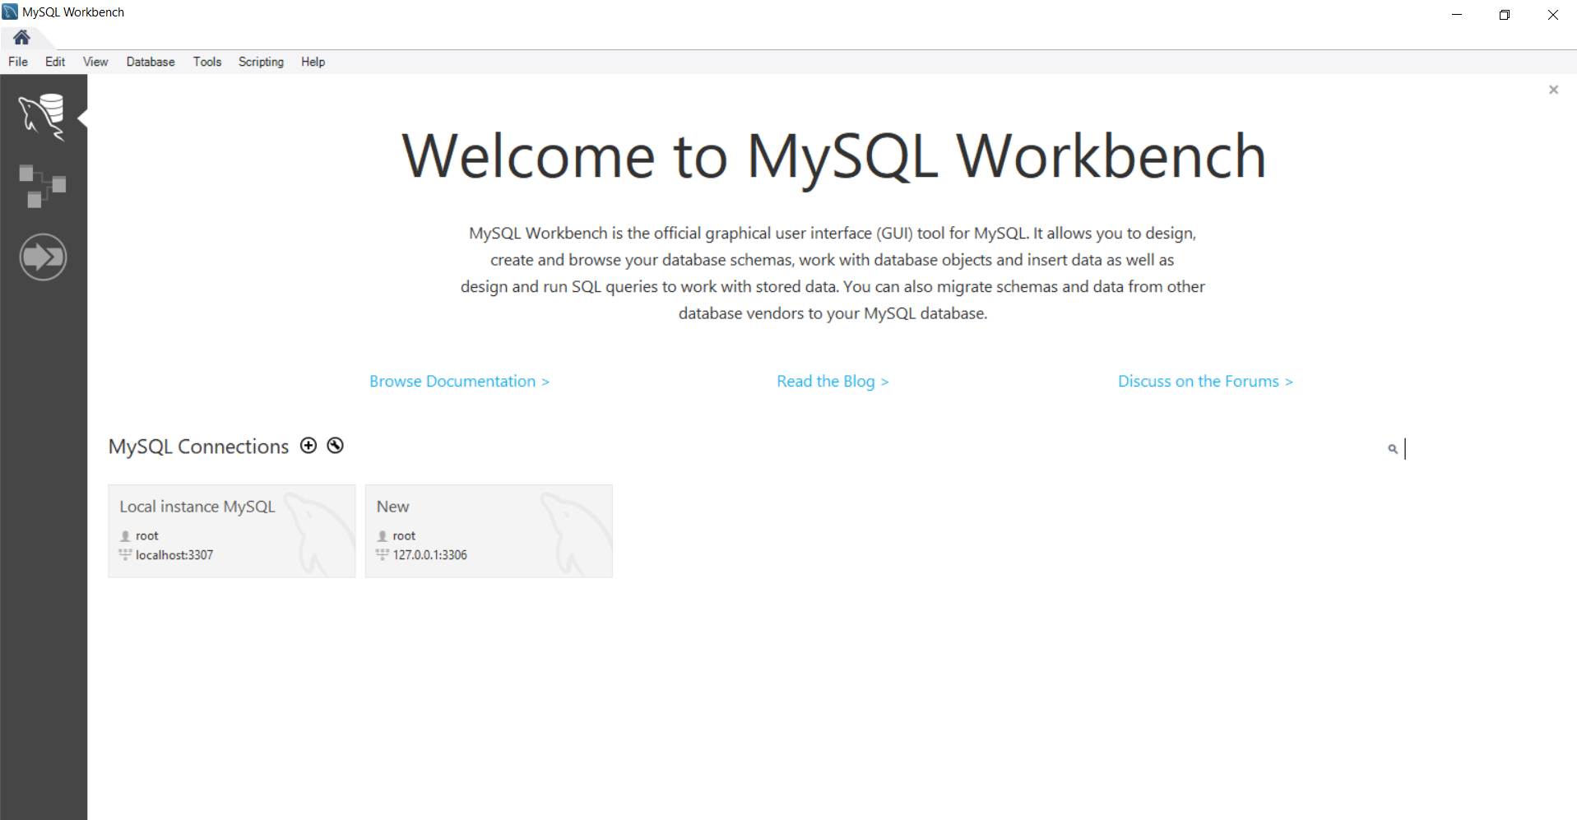

- Open project in Neat beans ide. Before run follow other guide lines.

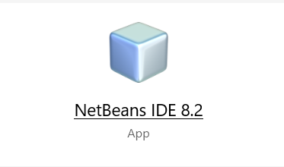

- Copy Paste jar files folder to your computer any location.(Desktop)

- Change Data base connection path to your computer data base path as bellow.

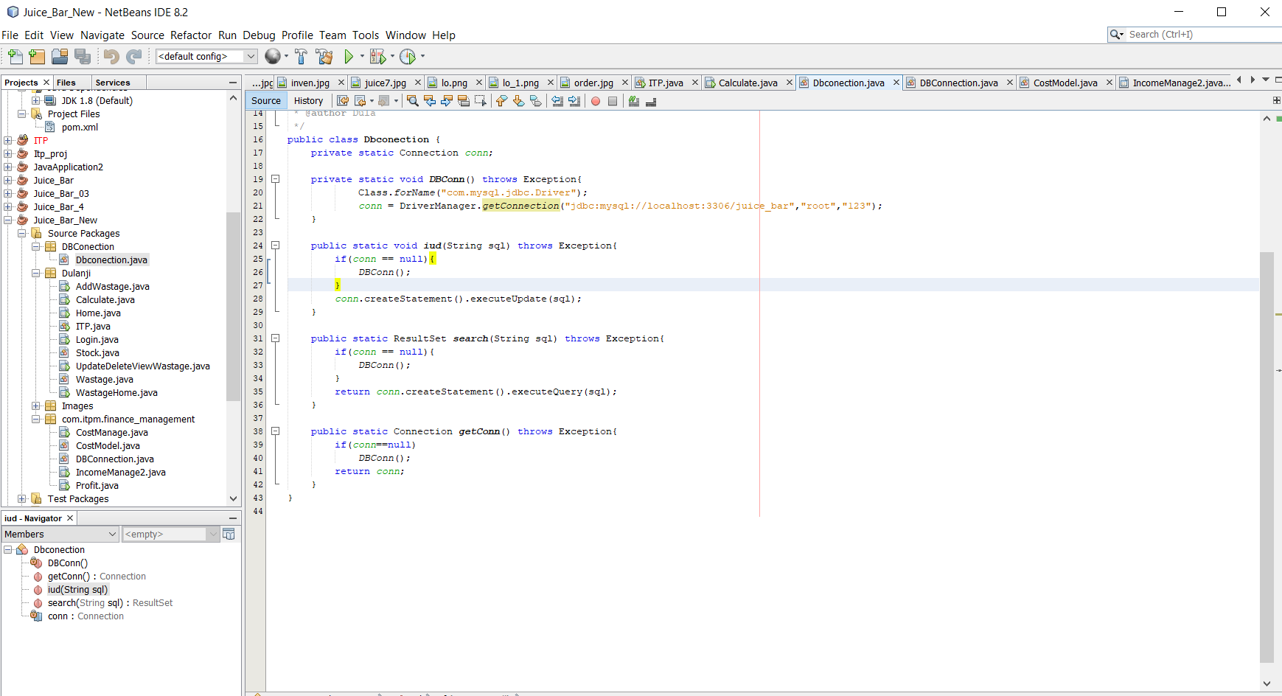

private static void DBConn() throws Exception{
Class.forName("com.mysql.jdbc.Driver");
conn = DriverManager.getConnection("jdbc:mysql://localhost:3306/juice_bar","root","123");
}
Data Base Name
MySQL user name in your computer
Password in MySQL

In here you have only change data base name, MySQL user name, Password.

- Like that change the following java files data base connection path according to your user name and password in MYSQL. Change following highlighted java classes path as above mentioned.
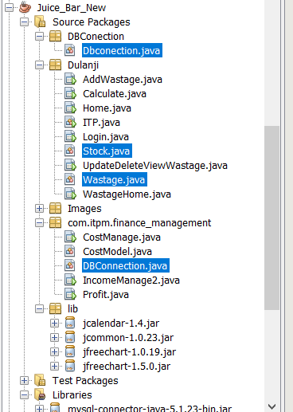

- Then run the project. Right click near the login page and then give (run file) command.

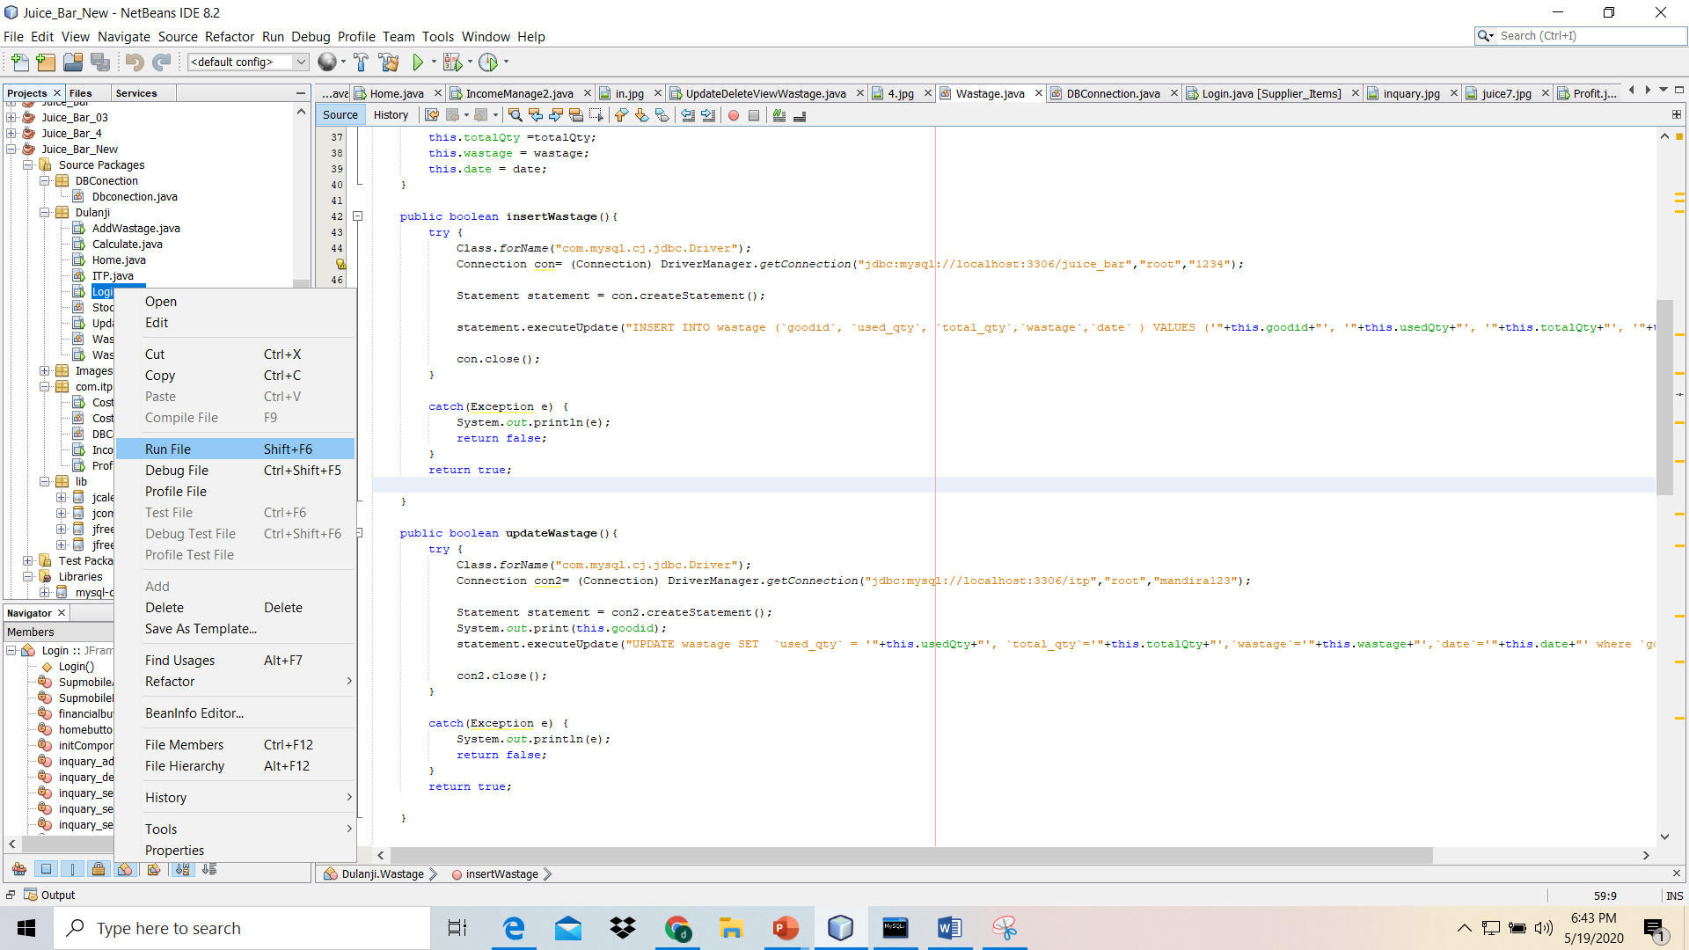

- Then run the project.

- When you run the project first you have to login. Then you use values in login table which we created early.

insert into login(username,password) values('Aloka','Aloka1');

insert into login(username,password) values('Dilika','Dilika1');

insert into login(username,password) values('Sumudu','Sumudu1');

- Then you can access the system.

- Our group one member have done his part in Java AFX. When integrate his part sometimes it gives errors so we include his part separately and other complete project and project with his part in source code folder

